Deterministic Model-based Reflex Agent

The Deterministic Model-based Reflex Agent is the most complex agent of three agents, because which action it takes depend on its state which is represented by its a small amount memory. For this paper, we are using Model-Based deterministic reflex agent with 3-bit memory as a vacuum cleaner which means its action depend on which state it hold currently, and its state changing depend on hitting the wall and current state. For example, the current state is 0, and if there is not wall in front of the cleaner, it will move forward. Then if it hit the wall, it will turn left, and the state change to 1. There are 7 states that are represented by 3-bit memory. The idea of this agent is showed in Fig.3. And the if-then rules of random reflex agent are listed in follow:

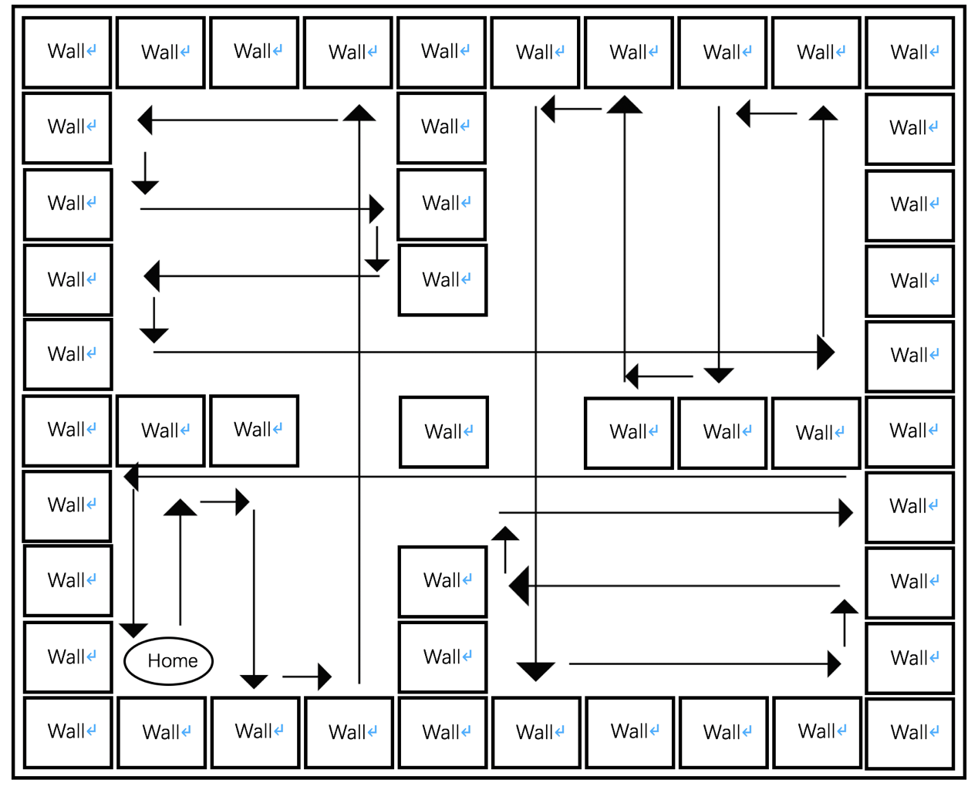

If the room is dirty, then suck up dirt

If not facing wall and the state is 0, then go forward.

If facing wall and the state is 0, then turn left and set the state to 1

If not facing wall and the state is 1, then go forward and set the state to 2

If facing wall and the state is 1, then turn left and set the state to 0

If the state is 2, then turn left and set the state to 3

If not facing wall and the state is 3, then go forward

If facing wall and the state is 3, then turn right and set the state to 4

If not facing wall and the state is 4, then go forward and set the state to 5

If facing wall and the state is 4, then turn left and set the state to 6

If the state is 5, then turn right and set the state to 0

If the state is 6, then turn left and set the state to 0

|  |  |  |  |
| --- | --- | --- | --- |
|  | Simple Agent | Random Agent(average) | Model-based Agent |
| Evn1.Total Dirty | 64 | 64.0 | 64 |
| Evn1.Total Cleaned | 28 | 37.48 | 64 |
| Evn1.Actions cost | 60 | 230.52 | 221 |
| Evn1.Efficiency | 0.4666667 | 0.1625889 | 0.2895927 |
| Evn1.Cleaned Percent | 0.4375 | 0.585625 | 1.0 |
|  |  |  |  |
| Evn2.Total Dirty | 53 | 53.0 | 53 |
| Evn2.Total Cleaned | 44 | 35.46 | 53 |
| Evn2.Actions cost | 104 | 329.58 | 161 |
| Evn2.Efficiency | 0.4230769 | 0.1075914 | 0.3291925 |
| Evn2.Cleaned Percent | 0.8301886 | 0.6690566 | 1.0 |

1. How does the memory-based deterministic agent perform in the two environments? Is it able to clean the room perfectly? How long does it take? Can the agent be improved with more memory?

In both environments, the memory-based deterministic agent we designed perform great. It perfectly cleans all of dirty and goes back to home. However, the efficiency is not too high, because it takes extra actions to go back home. It still can be improved with more memory to reduce useless actions. If we just can get more serval bit for memory, there must be more state for actions. If we can get 10MB or more, we can record path or door position, so it will be cleverer to clean more complex environments.

1. What are the tradeoffs between the random and deterministic agents? How would you design better agents for more complex environments, say with polygonal obstacles?

For the random reflex agent, although the total of dirty it cleaned is higher than simple reflex agent, it takes more action to clean, so the efficiency is not too high. However, for the deterministic agent, it always cleans the same position in the room, if it cannot clean all of the positions, it will be very bad, because some part of your room will always be dirty. Also, for different environments, the cleaned percentage of deterministic agent will be totally different, but for random agent, the average result will be closed.

For more complex environments, like polygonal obstacles, we think that the agent should be deigned to get more information of the environment, because the information is very important to make decision. Also, the best way is to learn the environment by random moving in the environment serval times, even the polygonal obstacles can be recorded, because the deterministic agents cannot reach every angle of the polygonal obstacles.

What did you learn from this experiment? Were you surprised by anything?

Surprised, the randomly reflex agent is better than we thought. It also can handle many kinds of environment. Random have to be very important part of future AI. It is easy to clean most of dirty if knowing the environment first. So, combining both of them is very important. Random for get information of environment, then creating serval model for cleaning this environment.